**Topic Name:**

The main aim of this lab session is to provide hands-on experience on

* Explore file structure
* File management commands
* Absolute path and Relative path
* Globbing
* Scripting

File Structure

1. Under the root directory there are many files like

/bin , /boot , /dev , /etc , ….

Find out the importance of those files

Example : /etc is for user account details

|  |  |  |
| --- | --- | --- |
| **S.No** | **Directory** | **Usage** |
| 1 | / | Root directory |
| 2 | /bin | Binary files |
| 3 | /boot | is a critical part of the system, as it contains the files needed to boot the operating system. |
| 4 | /dev | directory in Linux is a special and essential directory that contains device files. |
| 5 | /etc | directory in Linux is a crucial directory that contains system-wide configuration files and shell scripts used to manage the system. |
| 6 | /home | directory in Linux is where the personal directories of all user accounts are stored. |
| 7 | /lib | directory in Linux is a critical system directory that contains essential shared libraries and kernel modules required by the system and applications. |
| 8 | /proc | directory in Linux is a special and dynamic virtual filesystem that provides a mechanism for the kernel to communicate with user space. |
| 9 | /sbin | directory is integral to system administration and maintenance, providing the tools necessary for managing and repairing the system, particularly during boot and recovery operations. |
| 10 | /tmp | directory in Linux is a temporary storage space where programs and users can store transient files that are needed only temporarily. |
| 11 | /var | directory in Linux is a key directory that holds variable data—data that is expected to change frequently during the system's operation. |
| 12 |  |  |
| 13 |  |  |

1. In Linux, there are three different files

Regular file

Directory

Special file

Block file

Character file

Socket file

Pipe file

Fill the below table:

|  |  |  |  |  |  |  |
| --- | --- | --- | --- | --- | --- | --- |
| File Type | Represented by (Hint ls ) | Role | How to create | How to check | Location | Screen shot |
| Regular file | - | Stores data such as text images | touch t1 | NA |  |  |
| * Text file | - | Contains plain text | toucht1.txt | NA |  |  |
| * Compressed file | - | Stores data in a compressed format | gzip filename | NA |  |  |
| * Image | - | Stores image data | NA | NA |  |  |
| Directory | d | Contains files and other directories | mkdir filename | NA |  |  |
| Block file | b | Represents a block device | NA | NA |  |  |
| Character file | c | Represents a character device | NA | NA |  |  |
| Socket file | s | Provides interprocess communication(IPC) | NA | NA |  |  |
| pipe file | p | Used for IPC (inter – process communication) | NA | NA |  |  |

1. Globbing
2. Go back to CYS
3. Create multiple subdirectories using single command

LS

Unit1

command

glob

Unit2

command

grep

Unit3

Constructs

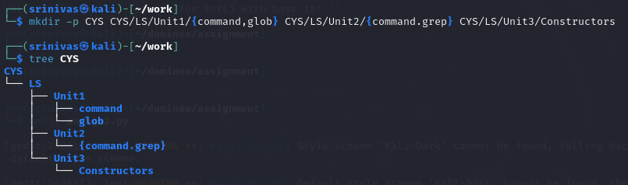

1. Navigate to unit1/glob



1. Create the following files :

Commands.txt

Commands1.txt

Commands2.txt

page1.html

page2.html

page3.html

file1

file10

file11

file2

File2

File3

file33

fileAB

filea

fileA

fileAAA

file(

file 2

* + 1. List all files starting with file



* + 1. List all files starting with File

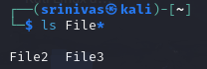

* + 1. List all files starting with file and ending in a number.

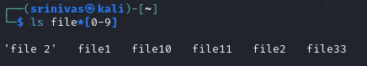

* + 1. List all files starting with file and ending with a letter

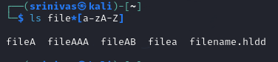

* + 1. List all files starting with File and having a digit as fifth character.

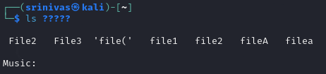

* + 1. List all files starting with File and having a digit as fifth character and nothing else.

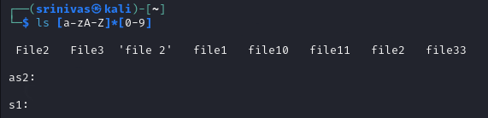

* + 1. List (with ls) all files starting with a letter and ending in a number.

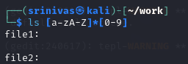

* + 1. List (with ls) all files that have exactly five characters.

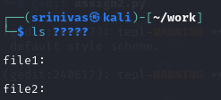

* + 1. List (with ls) all files that start with f or F and end with 3 or A.

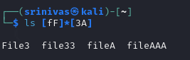

* + 1. List (with ls) all files that start with f have i or R as second character and end in a number.

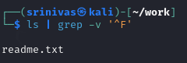

* + 1. List all files that do not start with the letter F.

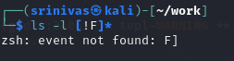

* + 1. Remove all the *.html



* + 1. Rename *.txt to *.json



1. Absolute path and relative path

Use rm, mv, cp, ls with absolute path and relative path as per your choice.

• Absolute **Path:** Specifies the location of a file or directory from the root directory. It is a complete path.

• Relative **Path:** Specifies the location of a file or directory relative to the current working directory.

1. Wildcards

|  |  |  |  |
| --- | --- | --- | --- |
| Notation | Use | Example | Screenshot |
| * | One or many | ls * |  |
| ? | Match only one character | ls file?.txt |  |
| [ ] | Used to match single character from a set of specified characters | ls file[1-3] |  |
| [! ] | Matches any character that is not a member of the set characters | ls file[!1].txt |  |
| { } | Used to generate multiple arguments by separating the values with commas | ls file{1,2}.txt |  |

More on Character class

|  |  |  |  |
| --- | --- | --- | --- |
| Notation | Use | Example | Screenshot |
| [:alnum:] | Matches any alphanumeric character | ls *[[:alnum:]].txt |  |
| [:alpha:] | Matches any alphabetic character | ls *[[:alpha:]].txt |  |
| [:digit:] | Matches any numeric digit (0-9). | ls *[[:digit:]].txt |  |
| [:lower:] | Matches any lowercase alphabetic character | ls *[[:lower:]].txt |  |
| [:upper:] | Matches any uppercase alphabetic character (A-Z) | ls *[[:upper:]].txt |  |

4. change permission

1. Change the permission set of /work/readme.txt so that only the user (owner) can read,write, and execute it. Use absolute mode.

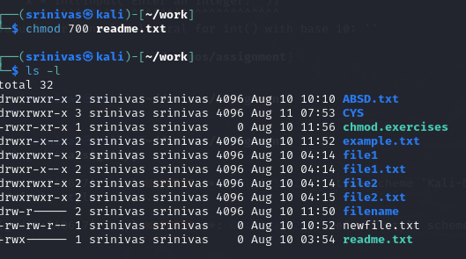

1. Change the permission set of /work/readme.txt so that any user can read it, the group can read/write to it and the user (owner) can read/write/execute it. Use absolute mode.

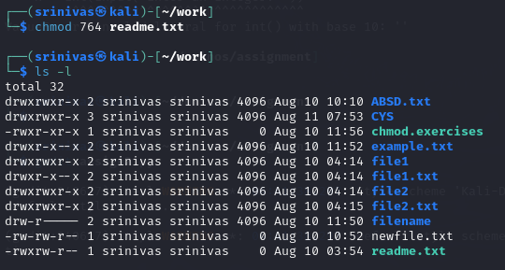

1. Change the permission set of /bin/bash so that only the user (owner) can read/write/ execute, group, and any user can execute it. However, whenever anyone executes it, it should run with the privileges of the owner user. Use absolute mode.

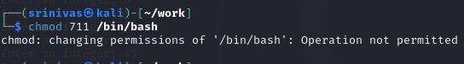

1. Change the permission set of /work/readme.txt so that only the user (owner) can read, write, and execute it. Use relative mode.

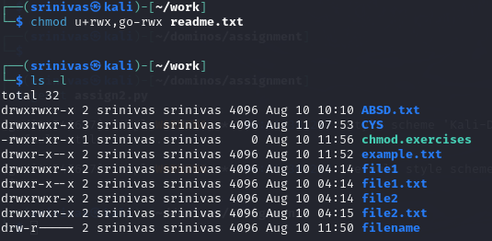

1. Change the permission set of /work/readme.txt so that any user can read it, the group can read/write to it and the user (owner) can read/write/execute it. Use relative mode.

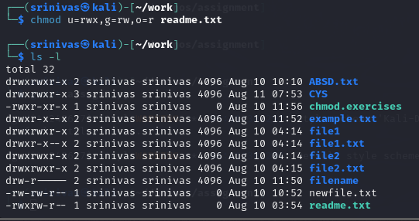

1. Change the permission set of /work/readme.txt so that only the user (owner) can read/write/ execute, group, and any user can execute it. However, whenever anyone executes it, it should run with the privileges of the group. Use absolute mode.

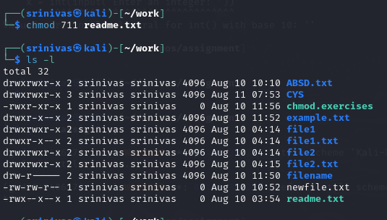

1. Change the permission set of /work/readme.txt so that only the owner can rename or delete this file while maintaining the existing permissions. Use absolute mode.

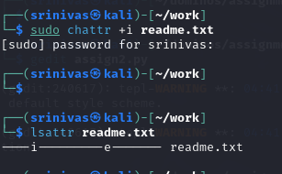

1. What are the default permissions for the new file?

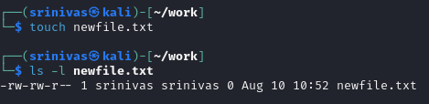

1. What was the command to view the file permissions?

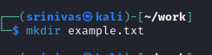

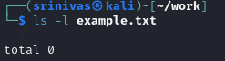

1. Change chmod.exercises permissions to -r--r--r—

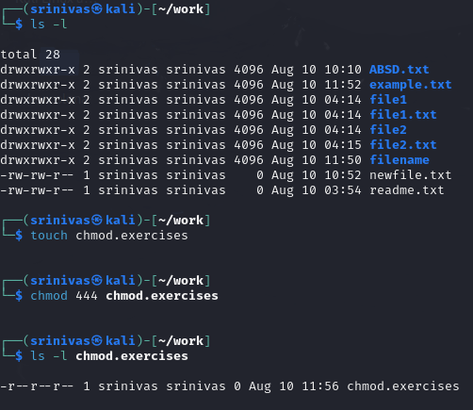

1. Change the file permissions to Read only for the owner, group and all other users.

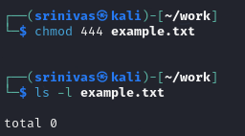

1. What was the command for changing the file permissions to -r--r--r--?

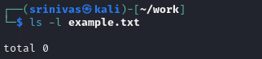

1. Change chmod.exercises permissions to -rw-r-----

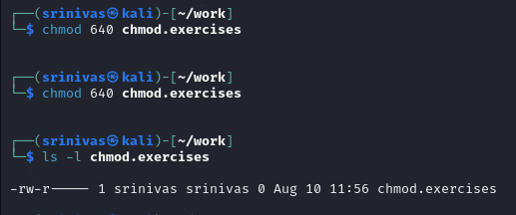

1. Change the file permissions to match the following:
   1. owner: Read and Write
   2. group: Read
   3. other: no permissions (None)

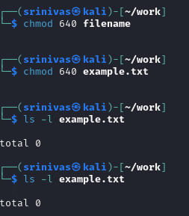

1. What was the command for changing the file permissions to -rw-r-----?

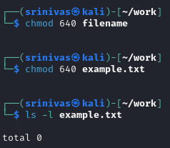

1. Change chmod.exercises permissions to -rwxr-x—x

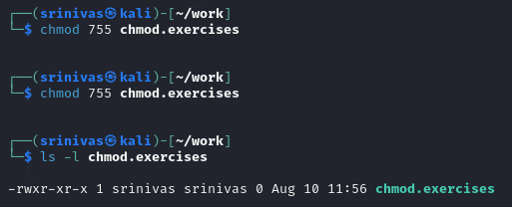

1. Change the file permissions to match the following:
   1. owner: Read, Write and Execute
   2. group: Read and Execute
   3. other: Execute

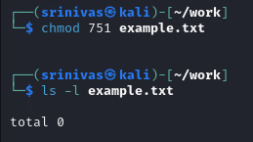

1. What was the command for changing the file permissions to -rwxr-x--x?



Evaluation :

Marks : 10 (Deadline : 4 – Originality :3 – Completeness :3 )

Deadline: 06.08.2024

In life there are no shortcuts. All things are connected. For success there is no fast lane. Work hard. Focus your energy, practice, remain honest, Truthful, loyal and committed.

-unknown